MAP AND DIRECTIONS TO JAM LOCATION

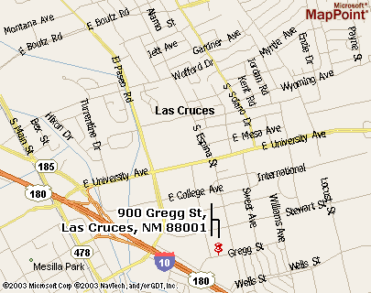

Jam Sessions

Southern New Mexico Music & Dance Society sponsors music jam sessions.
First and Third Sundays, 2 - 4 PM. Doña Ana Branch Community College, Room 129, Main Building
New Mexico State University campus, SW side.

http://www.zianet.com/lcludeman/contra/snmmds.html

Contact (575) 526-5174 for information.



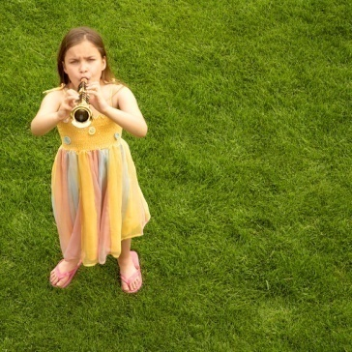
900 Gregg St., Las Cruces
Doña Ana Branch
Community College, Room 129, Main Building

Directions from I-10: exit 142 University, go east to Espina, turn right (south), 3 blocks to Gregg St, turn right (west), past small parking lot on left, around curve, then turn into first big parking lot on left, look for sign "Main Building" (across from sign "Trade Bldg"), go up the concrete steps, then listen for music coming from ROOM 129. It will be the only door open on Sunday.

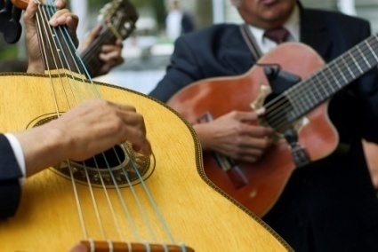


JOIN US !!

Open to musicians and listeners alike, a typical afternoon has each player choose tunes for all to play, and everyone takes a turn. We’ve had guitars, bass, mandolins, banjos, dobros, fiddles, and a very good sound. See what you can add!!

Jam Sessions
Southern New Mexico Music & Dance Society sponsors jam sessions from 2 - 4 PM on first and third Sundays, Doña Ana Branch Community College, Room 129, located on New Mexico State University campus, SW side. (See reverse for map and directions.)

http://www.zianet.com/lcludeman/contra/snmmds.html

Contact (575) 526-5174 for information.
Some tunes from previous jam sessions
Bar-B-Que | Blue Moon of Kentucky
I'll Fly Away | Old Home Place
Walking Blues | Joe Turner Blues
Crazy | City of New Orleans
Sunny | Arizona Waltz
Closer Walk With Thee | Salty Dog
Give My Love To Rose | Shackles & Chains
Wreck of the Old '97 | Is The Blue Moon Still Shining
Marvelous Toy | Kentucky Waltz
Westfalia Waltz | Brown-eyed Women
St. Louis Blues | Eight Miles to Louisville



